**BUG REPORT TEMPLATE**

**Bug ID**: *001*  
**Reported By**: *(Ahmed Ezzidin)*  
**Date**: *(06/05/2025)*  
**Environment**: *(Windows/Intellij)*

**Bug Details**

**Title**: *getStudentId() Method is not defined in any scope*  
**Severity**:  *High*  
**Priority**:  *High*

**Steps to Reproduce**

1. *Step 1: Run the main*
2. *Step 2: error is produced due to unresolved method getStudentId()*

OR

3. Search for getStudentId() in all of the project you’ll see the function is called in 3 scopes without actually being defined.

**Expected Behavior**

*The function is defined in Controller package to be called in other scopes & returns the Student ID for the Grade Listing to run successfully*

**Actual Behavior**

*getStudentid() is not resolved due to undefined calling and do not return the student’s id*

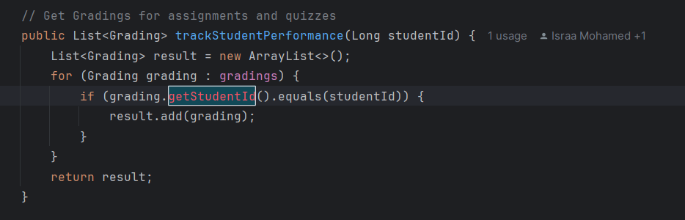**Attachments**

**BUG REPORT TEMPLATE**

**Bug ID**: *002*  
**Reported By**: *(Ahmed Nessal)*  
**Date**: *(06/05/2025)*  
**Environment**: *(Windows/Intellij)*

**Bug Details**

**Title**: *getCorrectAnswers() Method is not defined in any scope*  
**Severity**:  *High*  
**Priority**:  *High*

**Steps to Reproduce**

1. *Step 1: Run the main*
2. *Step 2: error is produced due to unresolved method getCorrectAnswers ()*

OR

3. Search for *getCorrectAnswers* () in all of the project you’ll see the function is called 1 time in correctAnswersCount(Long quizId, Long studentId)

**Expected Behavior**

*The function is defined in Controller package to be called in* correctAnswersCount(Long quizId, Long studentId) and returns all the correct answers the student made

**Actual Behavior**

*getCorrectAnswers* ()  *is not resolved due to undefined calling and does not return student’s correct answers.*

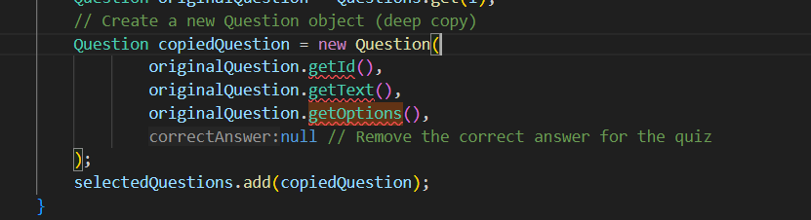**Attachments**

**BUG REPORT TEMPLATE**

**Bug ID**: *003*  
**Reported By**: *(Ahmed Mostafa)*  
**Date**: *(06/05/2025)*  
**Environment**: *(Windows/Intellij)*

**Bug Details**

**Title**: *getId() Method is not defined in (Question, Quiz, Assignment, Course, Lesson, Notification, User)*  
**Severity**:  *High*  
**Priority**:  *High*

**Steps to Reproduce**

1. *Step 1: Run the main*
2. *Step 2: error is produced due to unresolved method getId()*

OR

3. Search for *getId()* in all of the project you’ll see the function is called 18 times in the scopes mentioned in the title

**Expected Behavior**

*The function is defined in all the mentioned scopes to be called* and returns the specific Id for all scopes

**Actual Behavior**

*getId() is not resolved due to undefined calling and does not return the id.*

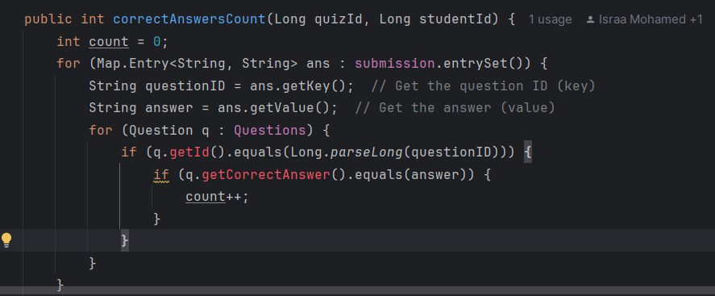**Attachments**

**BUG REPORT TEMPLATE**

**Bug ID**: *004*  
**Reported By**: *(Abd-El-Rahman Hossam)*  
**Date**: *(06/05/2025)*  
**Environment**: *(Windows/Intellij)*

**Bug Details**

**Title**: *getType () Method is not defined in Grading Model.*  
**Severity**:  *High*  
**Priority**:  *High*

**Steps to Reproduce**

1. *Step 1: Run the main*
2. *Step 2: error is produced due to unresolved method getType ()*

OR

3. Search for *getType ()* in all of the project you’ll see the function is called 1 time in grading

**Expected Behavior**

*The function is defined in Grading Model to be called in grading.getType* and returns the specific grading type for grading.

**Actual Behavior**

*getType() is not resolved due to undefined calling and does not return the Grading Type.*

**Attachments**

